Ф9,03 m Hard Rock Gripper TBM

For High Speed Railway Tunnel by CREG
General
August 1st, a Ф9,03 m hard rock TBM named ‘‘Caiyun’’ was unveiled in spring city Kunming. This big machine was designed and manufactured by CREG, integrated with several new technologies, which is dedicated to overcome the complex geology in Gaoligong Mountain.
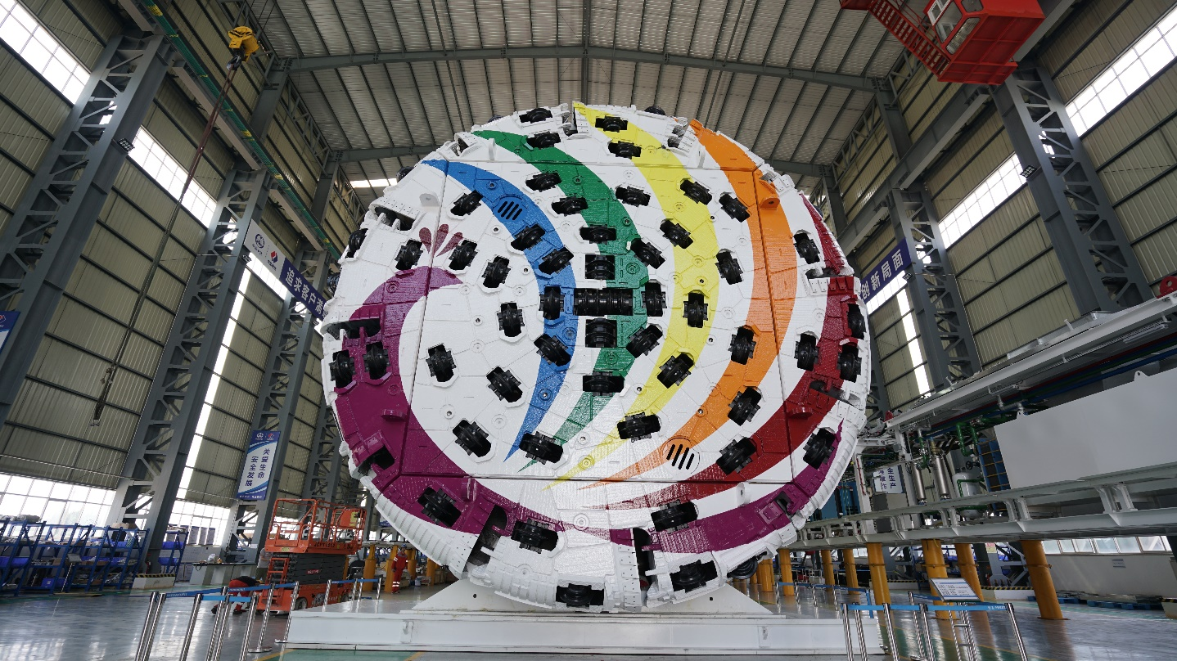
The project is located In Longling County of Yunnan Prov., where Gaoligong Mountain is straddling the border of southwestern China and northern Myanmar along the west bank of the Nujiang Valley. The tunnel is 12,8 km long with maximal overburden 1155m. Here the geology is extreme complex than ever before, can be summarized as follow:
- High geothermal
- High rock pressure
- High seismic intensity
- Active neo-tectonic movement
- Active geothermal system
Tunnel will be built mainly in Yanshanian granite, partially in Cambrian slate and dolomite. Four major faults were revealed by geotechnical survey.
Highlight
Some innovated technologies has been applied In order to adapt to the geological condition.
- Geological prediction system
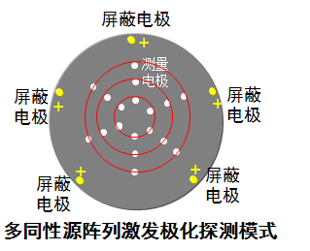
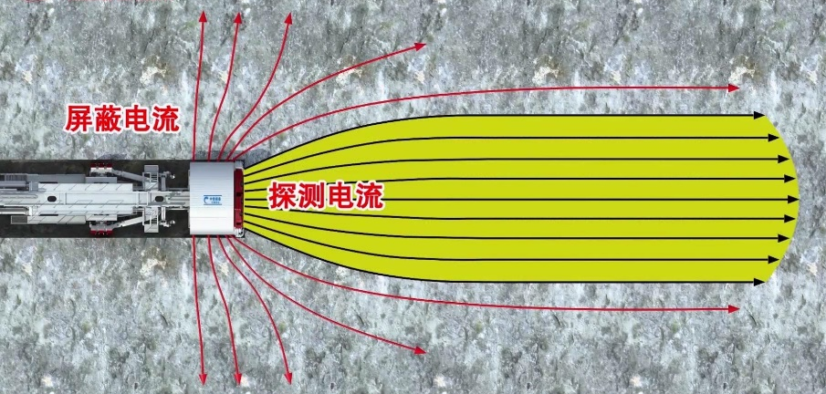
The most important thing is to predict the geology to make the appropriate adjustment of measures like rock bolting spraying concrete or pre-injection. TBM integrated totally 22 electrodes, 8 on the shield are considered as blind electrode and 14 on the cutter head is exciting electrode. Those electrodes allow the TBM to foresee geology 30 m far from the cutter head in real time.
Anomaly
Blind electrode
Exciting electrode
- Air cooler device
To reduce environmental temperature, TBM was installed three sets of air cooler system, one of three was reserved as an emergency system.
- Supporting system
Special steel bar arrangement has been applied to deal with the crushed and rock-blast area.
TBM characters
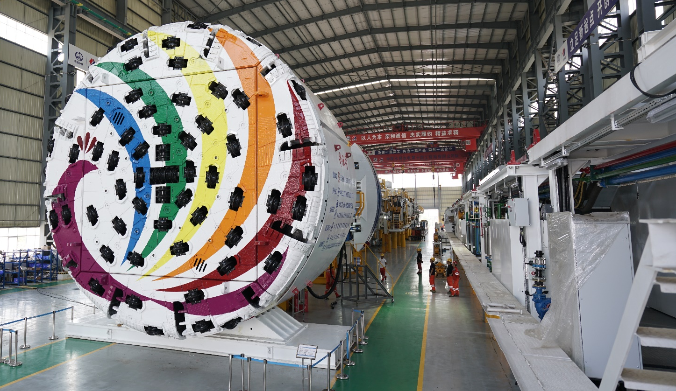
- Boring diameter: 9030 mm (can be increased to 9230 mm)
- Total Length: 230 m
- Total weight: 2000 ton
- Drive power: 12*350 kW
- Total power: 7200 kW
- Nominal torque: 11797 kN∙m
- Max. torque: 17695 kN∙m
- Rotation speed: 0-6,5 rpm
- Thrust force: 25133 kN
- Max. advance speed: 100 mm/min
- Min. turning curve: 500 m
- Max. muck discharge capability: 1030 ton/h

